PRACTICAL ASSIGNMENT- 8

* Name: Hardik Arora
* Branch : Btech - CS
* Program: AIML
* University Roll No. : 2215500071
* Section: 2AC
* Class Roll No. : 28

CREATE DATABASE P6;

USE P6;

CREATE TABLE IF NOT EXISTS Student (

    sID INT PRIMARY KEY,

    sName VARCHAR(50),

    GPA FLOAT,

    sizeHS INT NOT NULL,

    DoB VARCHAR(50)

);

INSERT INTO student(sID, sName, GPA, sizeHS, DoB) VALUES ('123', 'Amy', '3.9', '1000', '1996-06-26');

INSERT INTO student(sID, sName, GPA, sizeHS, DoB) VALUES ('234', 'Bob', '3.6', '1500', '1995-04-07');

INSERT INTO student(sID, sName, GPA, sizeHS, DoB) VALUES ('345', 'Craig', '3.5', '500', '1995-02-04');

INSERT INTO student(sID, sName, GPA, sizeHS, DoB) VALUES ('456', 'Doris', '3.9', '1000', '1997-07-24');

INSERT INTO student(sID, sName, GPA, sizeHS, DoB) VALUES ('567', 'Edward', '2.9', '2000', '1996-12-21');

INSERT INTO student(sID, sName, GPA, sizeHS, DoB) VALUES ('678', 'Fay', '3.8', '200', '1996-08-27');

INSERT INTO student(sID, sName, GPA, sizeHS, DoB) VALUES ('789', 'Gary', '3.4', '800', '1996-10-08');

INSERT INTO student(sID, sName, GPA, sizeHS, DoB) VALUES ('987', 'Helen', '3.7', '800', '1997-03-27');

INSERT INTO student(sID, sName, GPA, sizeHS, DoB) VALUES ('876', 'Irene', '3.9', '400', '1996-03-07');

INSERT INTO student(sID, sName, GPA, sizeHS, DoB) VALUES ('765', 'Jay', '2.9', '1500', '1998-08-08');

INSERT INTO student (sID, sName, GPA, sizeHS, DoB) VALUES ('654', 'Amy', '3.9', '1000', '1996-05-26');

INSERT INTO student (sID, sName, GPA, sizeHS, DoB) VALUES ('543', 'Craig', '3.4', '2000', '1998-08-27');

SELECT * FROM student;

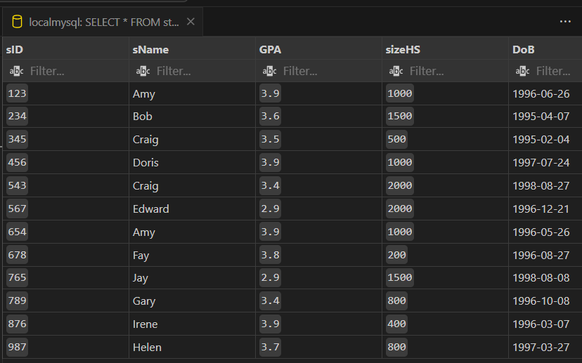

CREATE TABLE IF NOT EXISTS College(

    cName VARCHAR(50) PRIMARY KEY,

    State VARCHAR(50),

    enrollment INT NOT NULL

);

INSERT INTO college(cName, State, enrollment) VALUES('Stanford', 'CA', '15000');

INSERT INTO college(cName, State, enrollment) VALUES('Berkeley', 'CA', '36000');

INSERT INTO college(cName, State, enrollment) VALUES('MIT', 'MA', '10000');

INSERT INTO college(cName, State, enrollment) VALUES('Cornell', 'NY', '21000');

INSERT INTO college(cName, State, enrollment) VALUES('Harvard', 'MA', '50040');

SELECT * FROM college;

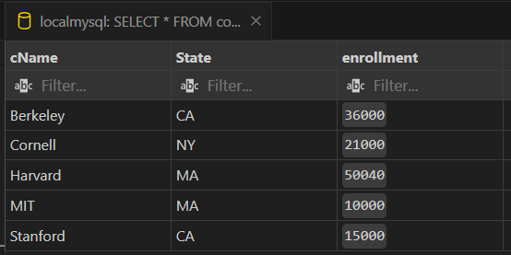

CREATE TABLE IF NOT EXISTS Applied(

    sID INT NOT NULL,

    cName VARCHAR(50) NOT NULL,

    major VARCHAR(50) NOT NULL,

    decision VARCHAR(1) NOT NULL

);

INSERT INTO Applied(sID, cName, major, decision) VALUES('123', 'Stanford', 'CS', 'Y');

INSERT INTO Applied(sID, cName, major, decision) VALUES('123', 'Stanford', 'EE', 'N');

INSERT INTO Applied(sID, cName, major, decision) VALUES('123', 'Berkeley', 'CS', 'Y');

INSERT INTO Applied(sID, cName, major, decision) VALUES('123', 'Cornell', 'EE', 'Y');

INSERT INTO Applied(sID, cName, major, decision) VALUES('234', 'Berkeley', 'biology', 'N');

INSERT INTO Applied(sID, cName, major, decision) VALUES('345', 'MIT', 'bioengineering', 'Y');

INSERT INTO Applied(sID, cName, major, decision) VALUES('345', 'Cornell', 'bioengineering', 'N');

INSERT INTO Applied(sID, cName, major, decision) VALUES('345', 'Cornell', 'CS', 'Y');

INSERT INTO Applied(sID, cName, major, decision) VALUES('345', 'Cornell', 'EE', 'N');

INSERT INTO Applied(sID, cName, major, decision) VALUES('678', 'Stanford', 'history', 'Y');

INSERT INTO Applied(sID, cName, major, decision) VALUES('987', 'Stanford', 'CS', 'Y');

INSERT INTO Applied(sID, cName, major, decision) VALUES('987', 'Berkeley', 'CS', 'Y');

INSERT INTO Applied(sID, cName, major, decision) VALUES('876', 'Stanford', 'CS', 'N');

INSERT INTO Applied(sID, cName, major, decision) VALUES('876', 'MIT', 'biology', 'Y');

INSERT INTO applied(sID, cName, major, decision) VALUES('876', 'MIT', 'marine biology', 'N');

INSERT INTO Applied(sID, cName, major, decision) VALUES('765', 'Stanford', 'history', 'Y');

INSERT INTO applied(sID, cName, major, decision) VALUES('765', 'Stanford', 'history', 'N');

INSERT INTO applied(sID, cName, major, decision) VALUES('765', 'Cornell', 'history', 'N');

INSERT INTO applied(sID, cName, major, decision) VALUES('765', 'Cornell', 'psychology', 'Y');

INSERT INTO applied(sID, cName, major, decision) VALUES('543', 'MIT', 'CS', 'N');

SELECT * FROM applied;

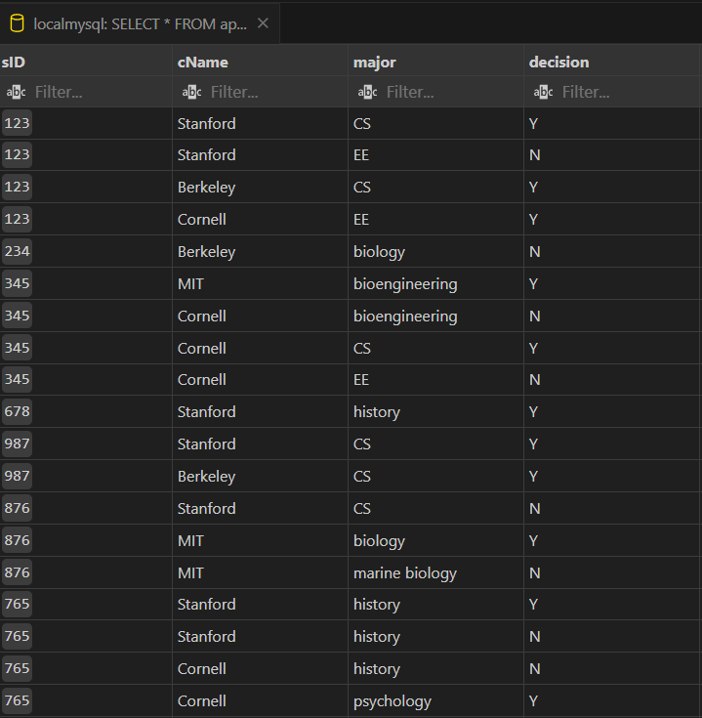

# Write SQL queries for the following:

Q1. As we need to notify in the system the birthday of each student, kindly create an index DoBindex on the column DoB of the Student table.

CREATE INDEX DoBindex ON Student(DoB);

- Q2. Which index would be more suitable for the major in Apply? Create a Bitmap Index named MAJORindex.

CREATE BITMAP INDEX MAJORindex ON Apply(major);

-- Q3. Remove the index on the DoB column.

DROP INDEX DoBindex;

-- Q4. Create a Unique index ENRindex on enrollment.

CREATE UNIQUE INDEX ENRindex ON College(enrollment);

-- Q5. Create a composite Unique index SCMindex on Apply using columns sID, cName, major.

CREATE UNIQUE INDEX SCMindex ON Apply(sID, cName, major);

-- Q6. Create a composite index on Apply using columns cName and major. Name this index as CMapplyINDX.

CREATE INDEX CMapplyINDX ON Apply(cName, major);

-- Q7. Create sequence sID_seq with the following parameters: increment by 3, cycle, cache 4, and which will generate the numbers among 988 to 999.

CREATE SEQUENCE sID_seq

INCREMENT BY 3

START WITH 988

MAXVALUE 999

CYCLE

CACHE 4;

-- Q8. Display the next value of Sequence sID_seq.

SELECT sID_seq.nextval FROM dual;

-- Q9. A new student entered the database named Eric with the next sID from sequence sID_seq having GPA 9.9, sizeHS 9999, DoB as '23-Apr-98' to the Student table.

INSERT INTO Student (sID, sName, GPA, sizeHS, DoB)

VALUES (sID_seq.nextval, 'Eric', 9.9, 9999, TO_DATE('23-Apr-98', 'DD-MON-YY'));

-- Q10. Now, another boy registered in our system named Troy with the next sID from sequence sID_seq having GPA 9.8 and sizeHS 989 and Dob as '25-Nov-99'.

INSERT INTO Student (sID, sName, GPA, sizeHS, DoB)

VALUES (sID_seq.nextval, 'Troy', 9.8, 989, TO_DATE('25-Nov-99', 'DD-MON-YY'));

-- Q11. Display details of the Student table and observe the newly inserted Eric and Troy sID.

SELECT * FROM Student;

-- Q12. Create a sequence GPA_seq having a maximum value of 5 and a minimum value of 3. You are supposed to start the sequence with 5 and decrement the sequence with -1, cycle and no cache.

CREATE SEQUENCE GPA_seq

START WITH 5

INCREMENT BY -1

MAXVALUE 5

MINVALUE 3

CYCLE

NOCACHE;

-- Q13. Update GPA of Eric to the next value of sequence GPA_seq.

UPDATE Student

SET GPA = GPA_seq.nextval

WHERE sName = 'Eric';

-- Q14. Insert student Jack with sID from sID_seq, GPA from GPA_seq, sizeHS as 1500, and DoB as '22-OCT-97'.

INSERT INTO Student (sID, sName, GPA, sizeHS, DoB)

VALUES (sID_seq.nextval, 'Jack', GPA_seq.nextval, 1500, TO_DATE('22-OCT-97', 'DD-MON-YY'));

-- Q15. Display details of the Student Table and observe GPA and sID of Jack.

SELECT * FROM Student WHERE sName = 'Jack';

-- Q16. Display the next value of sequence GPA_seq.

SELECT GPA_seq.nextval FROM dual;

-- Q17. Drop sequence sID_seq.

DROP SEQUENCE sID_seq;

-- Q18. Drop sequence GPA_seq.

DROP SEQUENCE GPA_seq;

* Name: Hardik Arora
* Branch : Btech - CS
* Program: AIML
* University Roll No. : 2215500071
* Section: 2AC
* Class Roll No. : 28
* Submitted to: Ayushi Mam
* Submitted on: 06-05-2024